**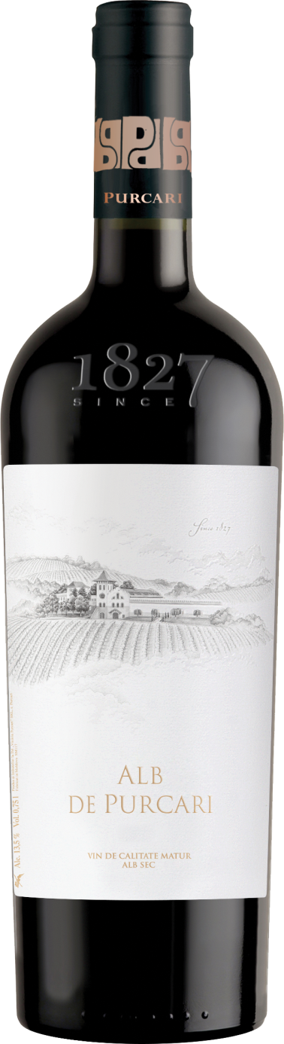G:\TANYA_WORK\WINE Sheets_New\WS_Template_Purcari\Logo_Purcari\Logo new 1827_logo.tif**

**Alb de Purcari 2019**

Protected Geographical Indication Stefan Voda

Aged Dry, White Wine

**Vinification:**

50% Chardonnay

35% Pinot Grigio

15% Pinot Blanc

Hand Harvested

Matured in French barrels for 6 months

**Product Information:**

Alb de Purcari – A sensual, slightly velvety experience that seduces your senses like a first love.

**Wine Tasting:**

With a beautiful light golden color, the wine has a complex aroma of sweet fruits, with an aftertaste of fine honey notes with spices. The full fruity taste is balanced with ample but delicate accents of oak. The acidity is well defined and extends the remarkable aftertaste.

**Recommended serving temperature:** +10...+12 °С

**Wine Analytics:**

Alcohol: 13,6%

Total acidity: 5,3 g/dm3

Total sugars: 1,0 g/dm3

**Awards:**

**Alb de Purcari 2019**

Gold Medal (*Vinarium International Wine Contest 2022*)

Gold Best of Show Moldova (*Galicja Vitis & Mundus Vini Germany Spring Tasting 2022*)

Gold Medal *(Mundus Vini Summer Tasting 2021)*

Gold Medal (Best in Show Moldova) *(USA Wine Ratings 2021)*

Gold Medal *(Vinarium IWCB 2021)*

Gold Medal *(AWC Vienna 2021)*

Silver Medal *(Concours Mondial de Bruxelles 2021)*

**Alb de Purcari 2018**

Gold Medal *(Challenge International du Vin, Bordeaux 2021)*

Gold Medal *(Citadelles du Vin 2021)*

Silver Medal *(Concours International de Lyon 2021)*

Silver Medal *(London Wine Competition 2021)*

**Alb de Purcari 2017**

Gold Medal *(International Wine Contest, Bucharest 2020)*

Gold Medal *(Eurasia Wine & Spirits Competition 2020)*

Gold Medal *(Mundus Vini Summer Tasting 2020)*

Gold Medal *(Concours Mondial de Bruxelles 2020)*

Silver Medal *(Challenge International du Vin, Bordeaux 2020)*

**VIVINO 4.4 Score** *(Equivalent to Robert Parker 88 points Wine Enthusiast 89 points)*

* Vinaria Purcari Vintage Collection Alb de Purcari Dry 2014 Decanter Asia Wine Awards 2017 Silver
* Vinaria Purcari Vintage Collection Alb de Purcari Dry 2014 International Wine & Spirit Competition 2017 Bronze
* Vinaria Purcari Vintage Collection Alb de Purcari Dry 2014 Challenge International du Vin, Bordeaux 2017 Gold
* Vinaria Purcari Vintage Collection Alb de Purcari Dry 2014 Black Sea Region & ExpoVin Moldova 2017 Gold
* Vinaria Purcari Vintage Collection Alb de Purcari Dry 2014 Mundus Vini Germany 2017 Gold
* Vinaria Purcari Vintage Collection Alb de Purcari Dry 2014 Sakura Japan Women’s Wine Awards 2017 Silver