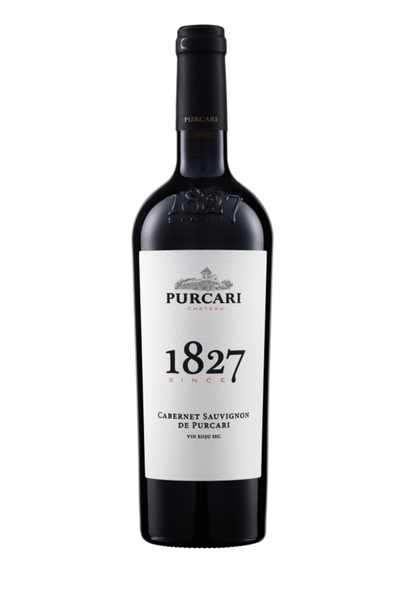**G:\TANYA_WORK\WINE Sheets_New\WS_Template_Purcari\Logo_Purcari\Logo new 1827_logo.tif**

**Cabernet Sauvignon de Purcari 2020**

Dry, Red Wine

**Vinification:**

100% Cabernet Sauvignon

Hand harvested.

Aged for 6 months.

**Product Information:**

Produced by the traditional method. It is a red wine with attitude: vigorous, virile, and robust.

**Wine Tasting:**

An intense ruby color flecked purple with a rich aroma, dominated by black cherry, complemented by fine notes of exotic spices. The taste is full, complex, with notes of ripe fruit, chocolate, vanilla and raisins. Soft tannins emphasize the roundness and softness of aftertaste with shades of ripening.

**Recommended serving temperature:** +18…+20°С

**Wine Analytics:**

Alcohol: 13.3%

Total acidity: 5,0g/dm3

Total sugars: 2.5 g/dm3

**Awards:**

**Cabernet Sauvignon 2020**

Silver Medal (*Decanter World Wine Awards 2022*)

Grand Gold ( *Concours Mondial de Bruxelles 2022*)

Gold Medal (*Eurasia Wine & Spirits Competition 2021*)

**Cabernet Sauvignon de Purcari 2019**

Silver Medal *(USA Wine Ratings 2021)*

**Cabernet Sauvignon de Purcari 2018**

Grand Gold Medal *(Oenoforum 2020)*

**Cabernet Sauvignon de Purcari 2017**

Bronze Medal (*Decanter Asia Wine Awards 2019)*

**Cabernet Sauvignon de Purcari 2016**

Silver Medal (*Decanter Asia Wine Awards 2018)*

**Cabernet Sauvignon de Purcari 2013**

Bronze Medal *(Decanter Asia Wine Awards 2015)*

**Cabernet Sauvignon de Purcari 2012**

Gold Medal *(Concours International de Vin 2015)*

**Cabernet Sauvignon de Purcari 2011**

Bronze Medal *(International Wine & Spirit Competition 2014)*

**VIVINO 4.4 Score** *(Equivalent to Robert Parker 90 points Wine Enthusiast 90 points)*