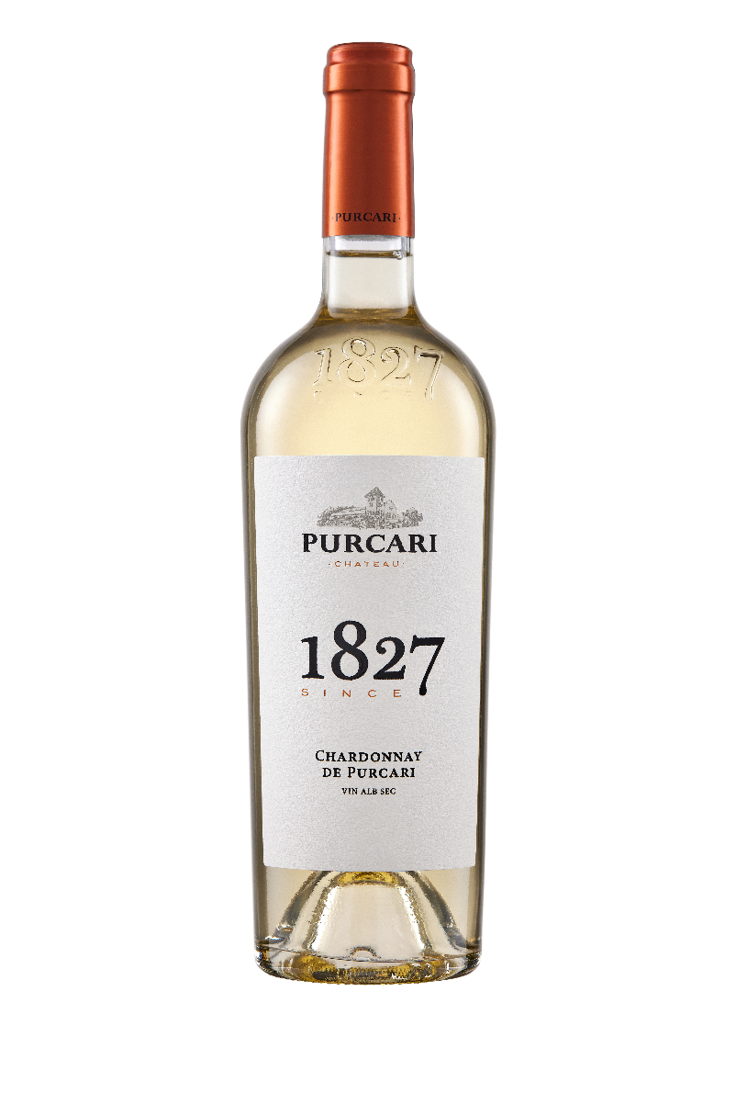**G:\TANYA_WORK\WINE Sheets_New\WS_Template_Purcari\Logo_Purcari\Logo new 1827_logo.tif**

**Chardonnay de Purcari 2021**

Dry, White Wine

**Vinification:**

100% Chardonnay

Hand Harvested.

Temperature-controlled fermentation in stainless steel and oak vessels

Aged for 6 months in French barrique

**Product Information:**

Chardonnay de Purcari will always remain the king of white wines: gorgeous, distinguished, and intense.

**Wine Tasting:**

It has an open golden color, with shades of amber. The intense aroma is dominated by flowers and exotic fruits. The full, opulent taste is complex, with notes of almond and vanilla, followed by a long aftertaste dominated harmoniously by shades of ripening.

**Recommended serving temperature:** +10... +12°С

**Wine Analytics:**

Alcohol: 13.26%

Total acidity: 6.6 g/dm3

Total sugars: 1.7 g/dm3

**Awards:**

**Chardonnay de Purcari 2021**

Bronze Medal (*Decanter World Wine Awards 2022*)

**Chardonnay de Purcari 2020**

Double Gold (*China Wine & Spirits Awards 2021*)

Gold Medal *(Concours International de Lyon 2021)*

Gold Medal *(Women's International Trophy 2021)*

Gold Medal *(Mundus Vini Summer Tasting 2021)*

Silver Medal *(AWC Vienna 2021)*

Silver Medal *(Vinalies Internationales 2021)*

Silver Medal *(London Wine Competition 2021)*

Silver Medal *(Vinarium IWCB 2021)*

**Chardonnay de Purcari 2019**

Gold Medal *(International Wine Contest, Bucharest 2020)*

Gold Medal *(Eurasia Wine & Spirits Competition 2020)*

Silver Medal *(Mundus Vini Summer Tasting 2020)*

**Chardonnay de Purcari 2018**

Platinum Medal (*Decanter World Wine Awards 2019)*

Gold Medal *(Black Sea Region & Expo Vin Moldova 2019)*

Gold Medal *(Concours Mondial de Bruxelles2019)*

Silver Medal (*Decanter Asia Wine Awards 2019)*

Bronze Medal (*International Wine and Spirit Competition 2019*)

**VIVINO 4.2 Score** *(Equivalent to Robert Parker 90 points Wine Enthusiast 88 points)*