**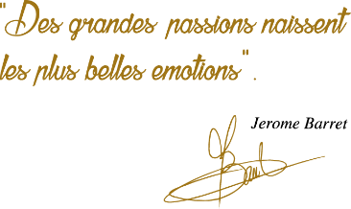G:\TANYA_WORK\WINE Sheets_New\WS_Template_Purcari\Logo_Purcari\Logo new 1827_logo.tif**

**Cuvée de Purcari Alb Brut**

White Brut Sparkling Wine

**Vinification:**

60% Chardonnay

30% Pinot Blanc

10% Pinot Noir

**Product Information:**

For you, almost two centuries of history and savor - Château Purcari brings through a creative fantasy, the Cuvée de Purcari sparkling wine, produced by using the classic method of fermentation. The finest terroirs are merged in an exceptional blend of Chardonnay, Pinot Noir and Pinot Blanc varieties.

**Wine Tasting:**

The long term maturation in bottles offers a soft and a persistent pearling. The golden tint of the sparkling wine is ennobled with a citrus flavor and a complex taste with peach nuances.

A genuine journey in time, along with Cuvée de Purcari!

**Recommended serving temperature:** +6 ... +10 °С

**Wine Analytics:**

Alcohol: 12,3%

Total acidity: 6.3 g/dm3

Total sugars: 7 g/dm3

**Awards:**

**Cuvée de Purcari Alb Brut 2018**

Gold Medal (Vinarium International Wine Contest 2022)

Gold Medal (Women’s International Trophy 2021)

Gold Medal *(IWSC International Wine & Spirit Competition 2021)*

Gold Medal *(Effervescents du Monde 2021)*

Gold Medal *(AWC Vienna 2021)*

Gold Medal *(Vinarium IWCB 2021)*

Gold Medal *(Citadelles du Vin 2021)*

Silver Medal *(London Wine Competition 2021)*

**Cuvée de Purcari Alb Brut 2017**

Gold Medal *(Challenge International du Vin, Bordeaux 2021)*

Gold Medal *(Eurasia Wine & Spirits Competition 2021)*

Gold Medal *(Mundus Vini Spring Tasting 2021)*

Gold Medal (*MundusViniGermany 2021)*

Gold Medal *(Vinarium IWCB 2021)*

Gold Medal *(Berliner Win eTrophy 2020)*

Gold Medal *(International Wine Contest, Bucharest 2020)*

**VIVINO 4.2 Score** *(Equivalent to Robert Parker 91 points Wine Enthusiast 90 points)*