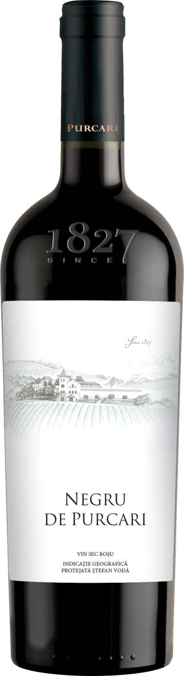**G:\TANYA_WORK\WINE Sheets_New\WS_Template_Purcari\Logo_Purcari\Logo new 1827_logo.tif**

**Negru de Purcari 2020**

Protected geographical Indication Stefan Voda

Aged Dry, Red Wine

**Vinification:**

* 55% Cabernet Sauvignon
* 40% Saperavi
* 5% Rară Neagră
* Hand Harvested
* Aged in oak French barrels for 18 months

**Product Information:**

* Purcari is putting Moldova on the world wine map will this famous noble blend ordered by the Royals of Europe for years. A complex conversation wine that is serious but approachable, elegant but ripe for drinking tonight while the rest of the case reaches its peak in the cellar.

**Wine Tasting:**

* Noble with a rich structure and a generous bouquet, it truly has a regal palate. Intense ruby color with garnet hue. This wine seduces with a velvety taste, balanced with oak and fruit tones. The bouquet surprises with fine shades of plums, chocolate, figs and develops, in time, revealing the fine aromas of vanilla and saffron. Negru de Purcari fascinates with a noble and magnificent taste, its value continuously increasing each year.
* **Recommended serving temperature:** +18... +20 °С

**Wine Analytics:**

* Alcohol: 13,7%
* Total acidity: 5,4 g/dm3
* Total sugars: 2,3 g/dm3

**Awards:**

* **Negru de Purcari 2019**

Gold Medal (Vinarium International Wine Contest 2022)

Gold Medal (*Vinarium IWCB 2021)*

* Gold Medal *(Women's International Trophy 2021)*
* Silver Medal (*Mundus Vini Summer Tasting 2021)*
* **Negru de Purcari 2018**

Gold Medal *(London Wine Competition 2021)*

* Silver Medal (*Concours Mondial de Bruxelles 2021)*
* **Negru de Purcari 2017**

Double Gold Medal (*China Wine and Spirits Awards 2020)*

Gold Medal (*Challenge International du Vin, Bordeaux 2020)*

* Gold Medal (*Berliner Wine Trophy Summer Tasting 2020)*

Gold Medal (*Oenoforum 2020)*

Gold Medal (*China Wine & Spirits Awards 2020)*

Gold Medal (*International Wine Contest, Bucharest 2020)*

* **Negru de Purcari 2016**

Champion - Grand Gold Medal *(Galicja Vitis, Poland 2019)*

* Gold Medal (*Berliner Wine Trophy 2020)*

Gold Medal (*International Wine Contest, Bucharest 2019)*

Gold Medal (*Vinarium IWCB 2021)*

**VIVINO 4.5 Score** *(Equivalent to Robert Parker 90 points Wine Enthusiast 90 points)*

*“This wine is like an iron fist, dressed in a velvet glove!”*

Federico Giotto,

Italian wine expert