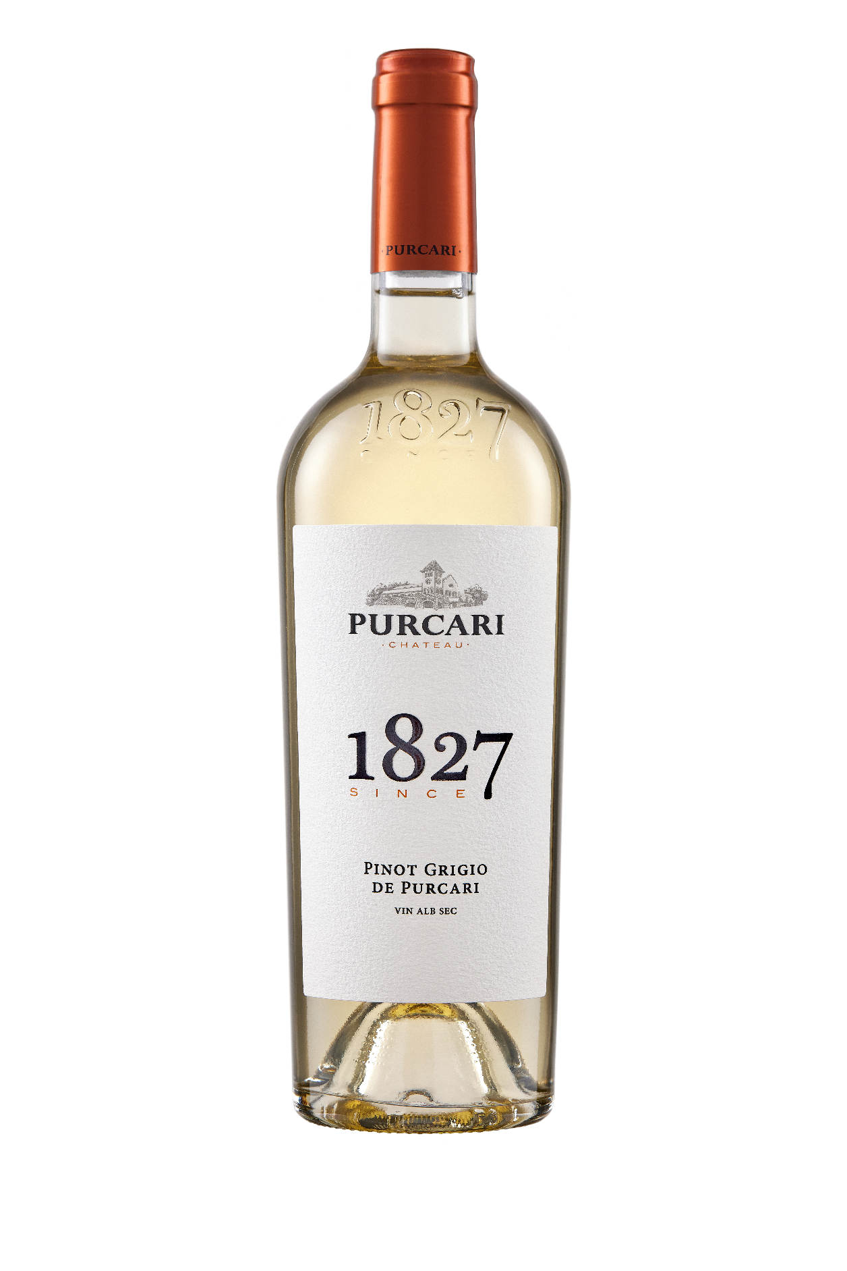**G:\TANYA_WORK\WINE Sheets_New\WS_Template_Purcari\Logo_Purcari\Logo new 1827_logo.tif**

**Pinot Grigio de Purcari 2021**

Dry, White Wine

**Vinification:**

100% Pinot Grigio

Hand Harvested.

Made in steel with no oak influences.

**Product Information:**

The grapes are hand-picked in September, cold alcohol-fermented in stainless tanks.

**Wine Tasting:**

The relatively pale colour with green highlights suggests this will be a Pinot Grigio in the Italian mode, but the nose and palate deliver a far more Alsatian experience, full-bodied, almost viscous, with exotic and candied fruit notes and an engagingly savoury note on the finish.

**Recommended serving temperature:** +10...+12°С

**Wine Analytics:**

Alcohol: 13.4%

Total acidity: 6.9 g/dm3

Total sugars: 2.2 g/dm3

**Awards:**

**Pinot Grigio de Purcari 2021**

Gold Medal (*Vinarium International Wine Contest 2022*)

Gold Medal (*Mundus Vini Germany Spring Tasting 2022*)

**Pinot Grigio de Purcari 2020**

Gold Medal *(International Wine & Spirit Competition 2021)*

Gold Medal *(Concours International de Lyon 2021)*

Gold Medal *(AWC Vienna 2021)*

Gold Medal *(USA Wine Ratings 2021)*

Silver Medal *(Mundus Vini Summer Tasting 2021)*

Silver Medal *(London Wine Competition 2021)*

Silver Medal *(Concours Mondial de Bruxelles 2021)*

**Pinot Grigio de Purcari 2019**

Gold Medal *(International Wine Contest, Bucharest 2020)*

Gold Medal *(Concours Mondial de Bruxelles 2020)*

**Pinot Grigio de Purcari 2018**

Gold Medal *(Eurasia Wine & Spirits Competition 2020)*

Gold Medal *(Challenge International du Vin, Bordeaux 2019)*

Gold Medal *(Black Sea Region & ExpoVin Moldova 2019)*

Silver Medal *(Challenge International du Vin, Bordeaux 2020)*

**Pinot Grigio de Purcari 2017**

Gold Medal *(Challenge International du Vin, Bordeaux 2018)*

Bronze Medal *(Decanter Asia Wine Awards 2018)*

**VIVINO 4.1 Score** *(Equivalent to Robert Parker 88 points Wine Enthusiast 87 points)*