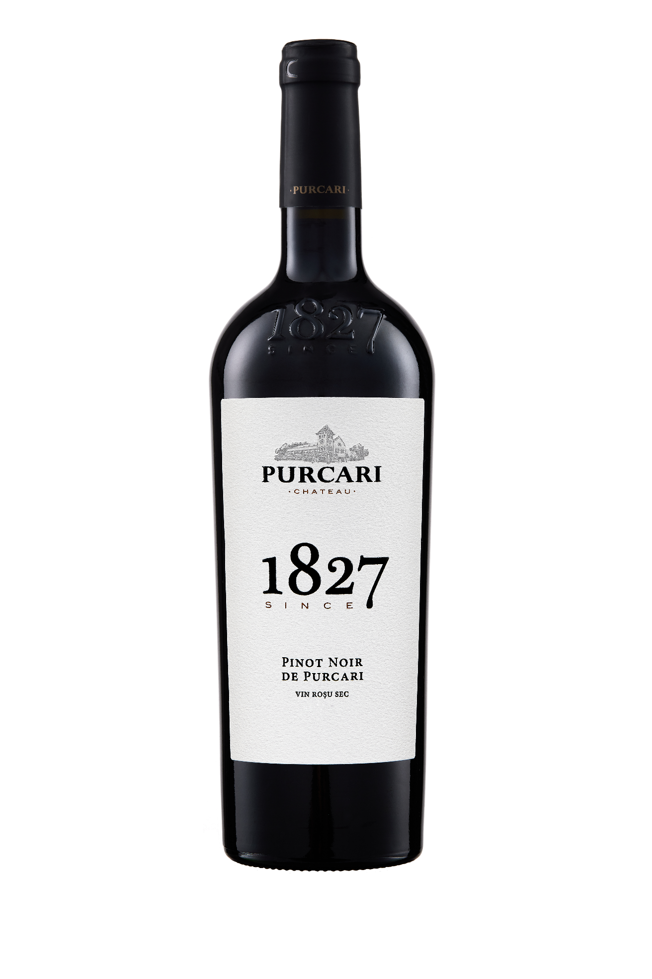**G:\TANYA_WORK\WINE Sheets_New\WS_Template_Purcari\Logo_Purcari\Logo new 1827_logo.tif**

**Pinot Noir de Purcari 2020**

Dry, Red Wine

**Vinification:**

100% Pinot Noir

Hand Harvested

Aged for 6 months

**Product Information:**

Pinot Noir de Purcari is a light and delicate wine like fine silk.

**Wine Tasting:**

The purplish red color is accompanied by a variety bouquet with complex aromas of strawberries, raspberries and violets. Velvety taste, full, persistent, passing in an aftertaste with fine nuances of maturation.

**Recommended serving temperature:** +18... +20 °С

**Wine Analytics:**

Alcohol: 12.8%

Total acidity: 5,0 g/dm3

Total sugars: 1.7 g/dm3

**Awards:**

**Pinot Noir de Purcari 2019**

Silver Medal *(AWC Vienna 2021)*

Commended (*Decanter World Wine Awards 2018)*

**Pinot Noir de Purcari 2016**

Silver Medal *(Decanter Asia Wine Awards 2018)*

Commended (*Decanter World Wine Awards 2018)*

**Pinot Noir de Purcari 2014**

88 points *(Wine Enthusiast Magazine 2017)*

**VIVINO 4.0 Score** *(Equivalent to Robert Parker 86 points Wine Enthusiast 88 points)*