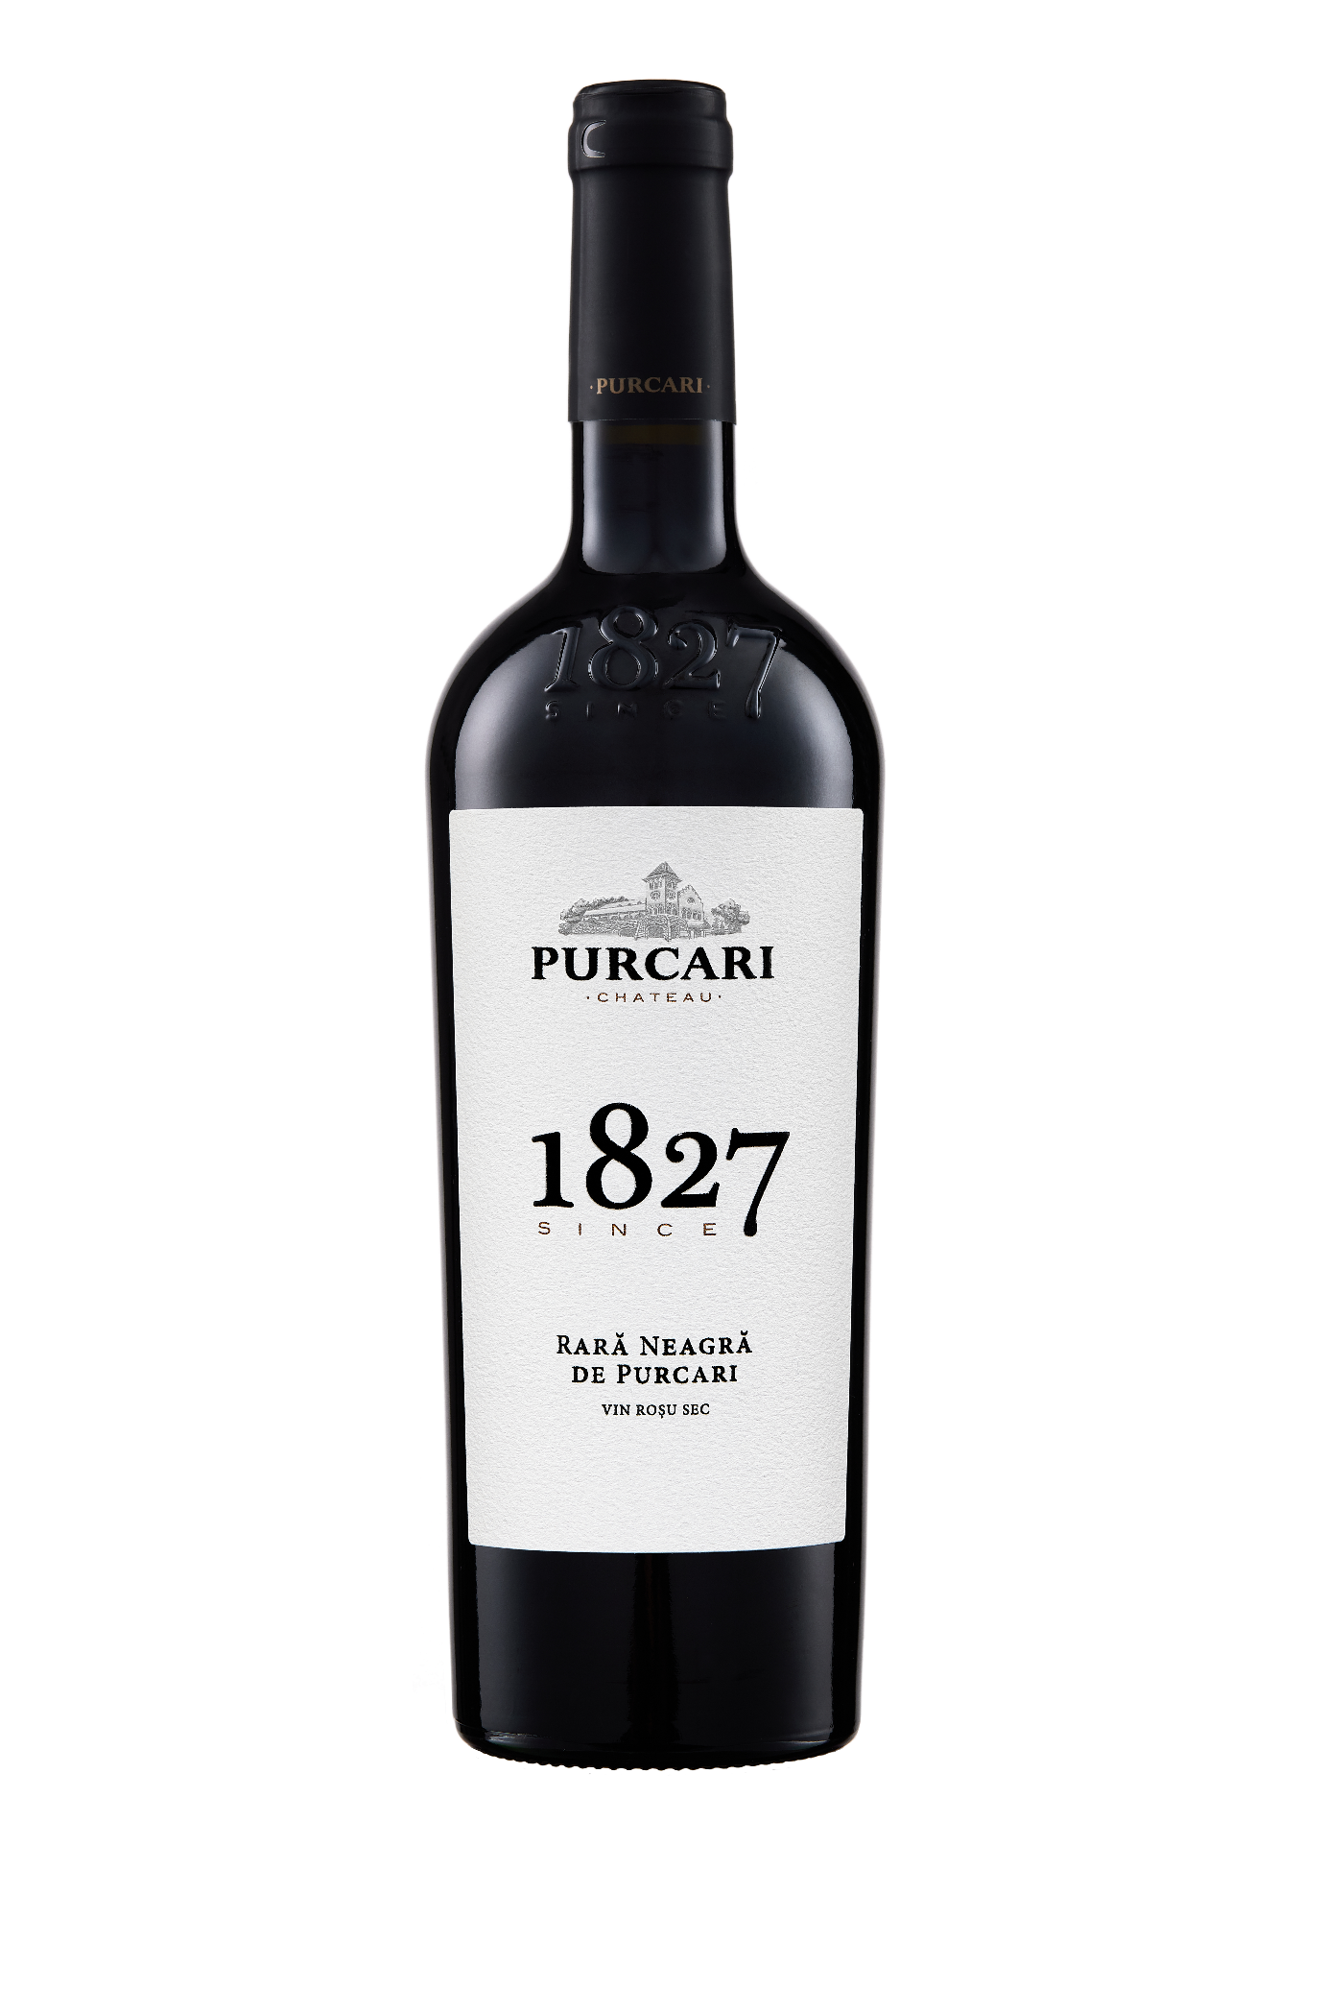**G:\TANYA_WORK\WINE Sheets_New\WS_Template_Purcari\Logo_Purcari\Logo new 1827_logo.tif**

**Rară Neagră de Purcari**

Dry, Red Wine

2021 vintage

**Vinification:**

100% Rară Neagră

Hand Harvested

Aged for 6 months

**Product Information:**

A lost page from the Grenache Diaries! No man is an island...but Moldova may be the Galapagos of wine. For centuries, this region has evolved virtually undisturbed by the West. To sip Rară Neagră is to discover a distinctive, low-tannin, high-acid gem that feels as at-home in the Rhone or Sardinia. Rară Neagră is the culmination of grace and elegance.

**Wine Tasting:**

It pours an inviting, not too dense garnet red, with a really delightful nose: dried herbs and juicy red cherries, a touch of pomegranate and floral lift and plenty of pepper and spice. In the mouth it is medium-bodied and fresh, a really good core of red fruits is dancing and agile on the tongue, and whilst the tannins are smooth and gentle, there is spice and there is acidity to give this some structure and some real presence into the finish.

**Recommended serving temperature:** +18... +20 °С

**Wine Analytics:**

Alcohol: 13,2%

Total acidity: 5,4 g/L

Total sugars: max.4,1 g/L

**Awards:**

**Rară Neagră de Purcari**

Silver Medal (*Decanter World Wine Awards 2022*)

Silver Medal (*Concours Mondial de Bruxelles 2022*)

**Rară Neagră de Purcari 2020**

Silver Medal (*Decanter World Wine Awards 2022*)

Silver Medal (*Concours Mondial de Bruxelles 2022*)

Gold Medal *(AWC Vienna 2021)*

Silver Medal *(Mundus Vini Summer Tasting 2021)*

Silver Medal *(USA Wine Ratings 2021)*

**Rară Neagră de Purcari 2019**

Silver Medal *(London Wine Competition 2021)*

Gold Medal *(Decanter World Wine Awards 2020)*

Gold Medal *(China Wine and Spirits Awards 2020)*

**Rară Neagră de Purcari 2018**

Silver Medal *(Decanter Asia Wine Awards 2019)*

**Rară Neagră de Purcari 2017**

Silver Medal *(Mundus Vini Germany 2019)*

Bronze Medal *(Decanter World Wine Awards 2019)*

Bronze Medal *(International Wine & Spirit Competition 2019)*

**VIVINO 4.3 Score** *(Equivalent to Robert Parker 89 points Wine Enthusiast 89 points)*