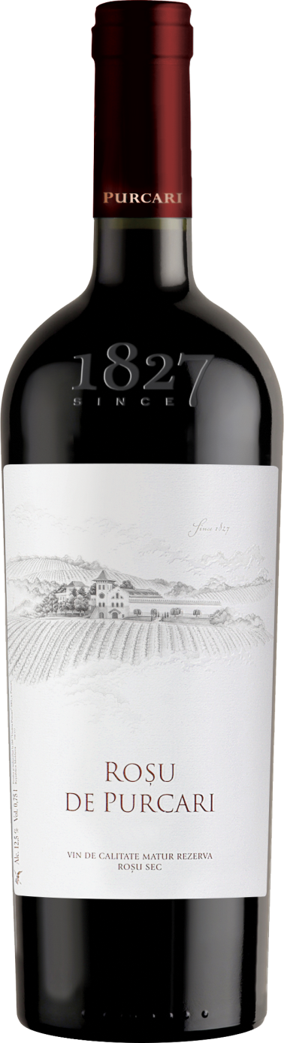**G:\TANYA_WORK\WINE Sheets_New\WS_Template_Purcari\Logo_Purcari\Logo new 1827_logo.tif**

**Roșu de Purcari 2018**

Protected Geographical Indication Stefan Voda

Aged Dry, Red Wine

**Vinification:**

* 50% Cabernet Sauvignon
* 35% Merlot
* 15% Malbec
* Hand Harvested
* Oaked in French barrels for 18 months

**Product Information:**

Every great wine region has an ageable red. In this red blend, Purcari hums a familiar Bordeaux tune in the key of Moldova. In any language, it’s a symphony. Roșu de Purcari is a revelation of traditions: mature, rich and full of flavor.

**Wine Tasting:**

* This finesseful cuvée is a food-pairing dream, offering notes of forest fruits and plums that develop in time revealing delicate tints of sweet vanilla. The fruit flavor surprises through its refinement, deepness and smoothness, ensuring a long lasting aftertaste.
* **Recommended serving temperature:** +18... +20 °С

**Wine Analytics:**

* Alcohol: 13,35%
* Total acidity: 5,6 g/dm3
* Total sugars: 1,0 g/dm3

**Awards:**

**Roșu de Purcari 2018**

Double Gold (China Wine & Spirits Awards 2021)

* **Roșu de Purcari 2017**
* Gold Medal (*Selection Mondial du Vin Canada 2021*)
* **Roșu de Purcari 2012**
* Rated with 90 points - excellent; highly recommended (Wine Enthusiast Magazine 2017)
* Rated with 90 points - excellent; highly recommended (Wine Enthusiast Magazine 2016)
* **Roșu de Purcari 2010**
* Rated with 90 points - excellent; highly recommended (Wine Enthusiast Magazine 2015)

**VIVINO 4.4 Score**