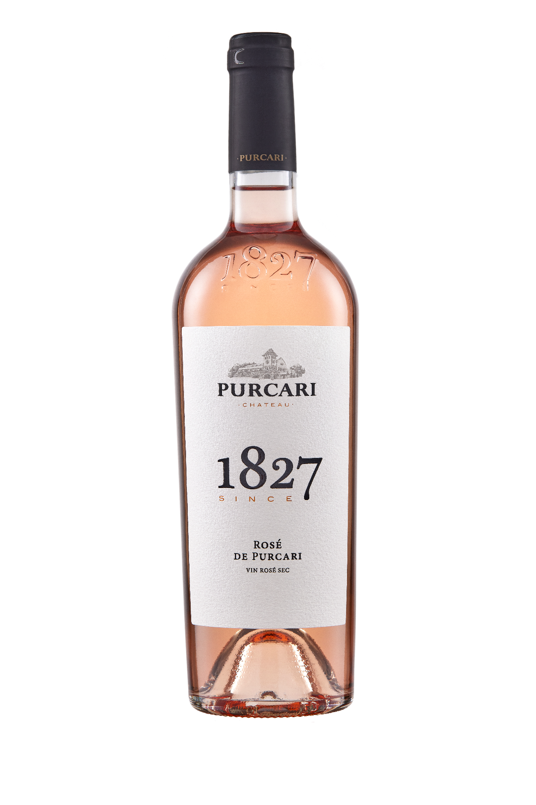**G:\TANYA_WORK\WINE Sheets_New\WS_Template_Purcari\Logo_Purcari\Logo new 1827_logo.tif**

**Rosé de Purcari 2021**

Dry, Rosé Wine

**Vinification:**

60% Cabernet Sauvignon

30% Merlot

10% Rară Neagră

Hand Harvested

Made in steel with no oak influences

**Product Information:**

Rosé de Purcari is a refined spring day in an orchard of apricot blossoms.

**Wine Tasting:**

The pink color is accompanied by a delicate aroma of exotic fruits. Sweet taste with notes of apricot, peach, and blackcurrant, passing slowly in an extended aftertaste with notes of berries.

**Recommended serving temperature:** +10... +12°С

**Wine Analytics:**

Alcohol: 13.46%

Total acidity: 6.6 g/dm3

Total sugars: 2.7 g/dm3

**Awards:**

**Rosé de Purcari 2021**

Grand Gold ( *Concours Mondial de Bruxelles Rose Selection 2022*)

Silver Medal (*Mundus Vini Germany Spring Tasting 2022*)

Silver Medal (*Vinarium International Wine Contest 2022*)

Silver Medal (*Decanter World Wine Awards 2022*)

**Rosé de Purcari 2020**

Gold Medal *(Vinalies Internationales 2021)*

Silver Medal *(AWC Vienna 2021)*

Silver Medal *(London Wine Competition 2021)*

Silver Medal *(Concours Mondial de Bruxelles 2021)*

Silver Medal *(Mundus Vini Summer Tasting 2021)*

Silver Medal *(Mondial du Rose 2021)*

**Rosé de Purcari 2019**

Gold Medal *(International Wine Contest, Bucharest 2020)*

Silver Medal *(Decanter World Wine Awards 2020)*

Silver Medal *(China Wine and Spirits Awards 2020)*

**Rosé de Purcari 2018**

Gold Medal (*International Wine Contest, Bucharest 2019)*

Silver Medal *(Challenge International du Vin, Bordeaux 2019)*

Silver Medal *(Mundus Vini Germany 2019)*

**Rosé de Purcari 2017**

Gold Medal *(Mondial du Rose 2018)*

Gold Medal *(Challenge International du Vin, Bordeaux 2018)*

Silver Medal *(Concours Mondial de Bruxelles 2018)*

**VIVINO 4.1 Score** *(Equivalent to Robert Parker 88 points Wine Enthusiast 89 points)*