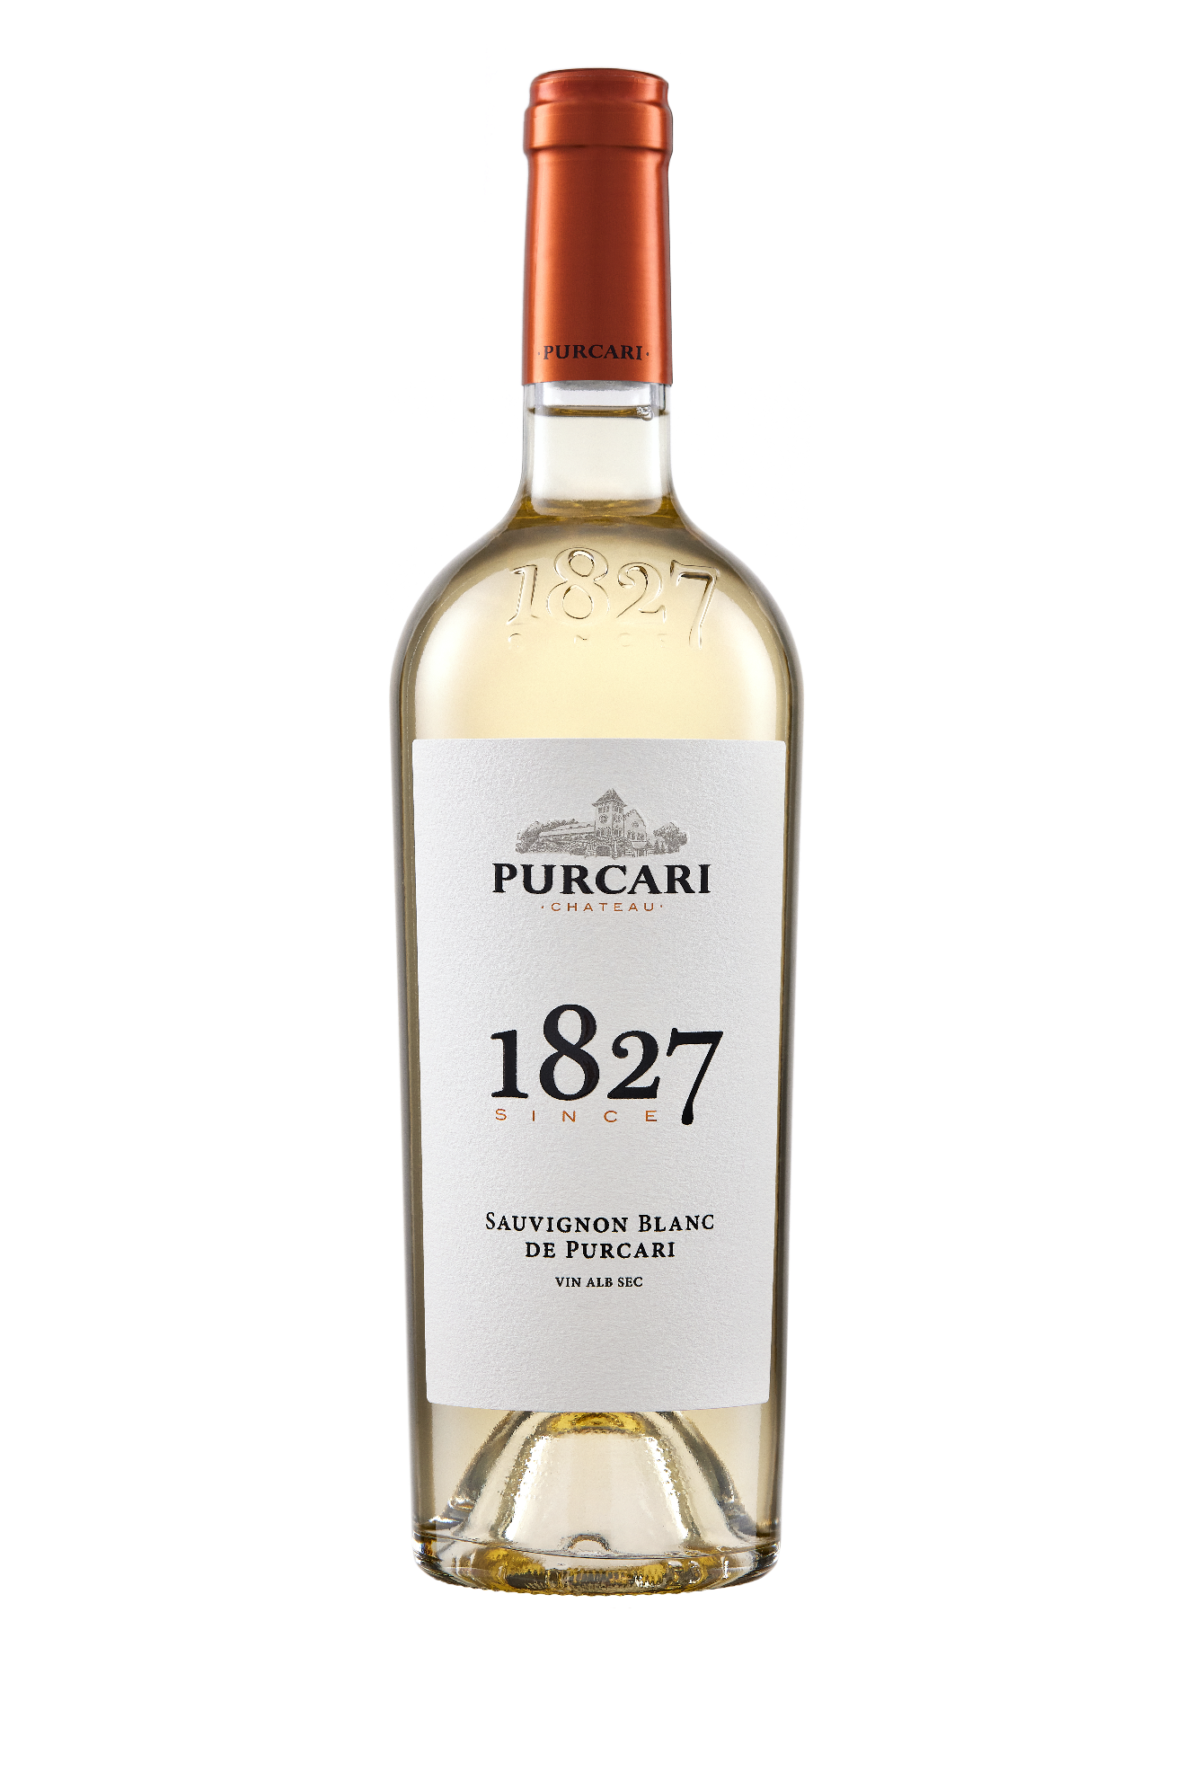**G:\TANYA_WORK\WINE Sheets_New\WS_Template_Purcari\Logo_Purcari\Logo new 1827_logo.tif**

**Sauvignon Blanc de Purcari**

Dry, White Wine

2021 vintage

**Vinification:**

100% Sauvignon Blanc

Hand Harvested

Made in steel with no oak influences.

**Product Information:**

The grapes are hand-picked in September, cold alcohol-fermented in stainless steel tanks. This wine smells of pure summer delight, with an amazingly fruit-flavored profile.

**Wine Tasting:**

Close your eyes, waft the glass to your nose, take a deep breath and with a little imagination, you will escape directly into a field of flowers. What makes Sauvignon unique from other white wines are its herbaceous flavors like bell pepper, jalapeño, gooseberry and grass. The primary fruit flavors of Sauvignon Blanc de Purcari are lime, green apple, passion fruit and white peach.

**Recommended serving temperature:** +10... +12°С

**Wine Analytics:**

Alcohol: 13,2%

Total acidity: 7,5 g/L

Total sugars: max.4 g/L

**Awards:**

**Sauvignon Blanc de Purcari 2021**

Gold Medal – Best of Show Moldova (*Mundus Vini Summer Tasting 2022*)

Gold Medal (*Mundus Vini Germany Spring Tasting 2022*)

Gold Medal (*Vinarium International Wine Contest 2022*)

Bronze Medal (*Decanter World Wine Awards 2022*)

**Sauvignon Blanc de Purcari 2020**

Gold Medal *(Mundus Vini Spring Tasting 2021)*

Gold Medal *(Women's International Trophy 2021)*

Silver Medal *(London Wine Competition 2021)*

Silver Medal *(AWC Vienna 2021)*

Silver Medal *(Vinalies Internationales 2021)*

**Sauvignon Blanc de Purcari 2019**

Gold Medal *(International Wine Contest, Bucharest 2020)*

Gold Medal *(Asia Wine Trophy 2020)*

Silver Medal *(Mundus Vini Spring Tasting 2020)*

Silver Medal *(Challenge International du Vin, Bordeaux 2020)*

**Sauvignon Blanc de Purcari 2018**

Gold Medal *(Challenge International du Vin, Bordeaux 2019)*

Gold Medal (*International Wine Contest, Bucharest 2019)*

Gold Medal *(Black Sea Region & ExpoVin Moldova 2019)*

Silver Medal *(Concours Mondial de Bruxelles2019)*

Silver Medal *(Mundus Vini Germany 2019)*

**VIVINO 3.9 Score** *(Equivalent to Robert Parker 86 points Wine Enthusiast 88 points)*