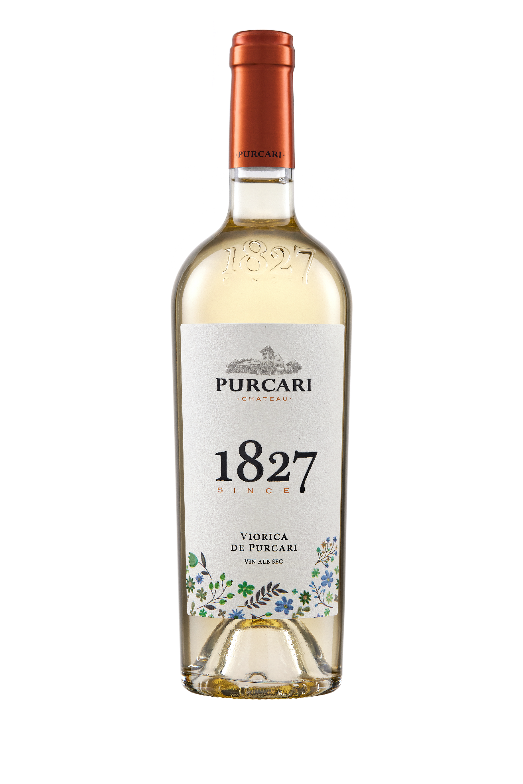**G:\TANYA_WORK\WINE Sheets_New\WS_Template_Purcari\Logo_Purcari\Logo new 1827_logo.tif**

**Viorica de Purcari 2021**

Dry, White Wine

**Vinification:**

100% Viorica

Hand Harvested.

Made in steel with no oak influences.

**Product Information:**

The Viorica grape variety is a variety with individuality: it appeared in Moldova in 1969, following a successful winemaking experiment. "The Parents" of Viorica are two red grape varieties - Seibel and Aleatico. Paradoxically the result of crossing was a white grape variety. Certainly, Viorica de Purcari is a noble class jewel.

**Wine Tasting:**

Viorica wine is made entirely from Viorica grapes, harvested manually and vinified by the traditional method. The white wine Viorica de Purcari is a sensory explosion: it has the aroma of acacia and basil flowers, it is fresh, easy and memorable. The golden color, with bright amber shades, is complemented wonderfully with its balanced and velvety taste and the fine taste of muscatel. Viorica conquers through its complex aroma and subtle finesse.

**Recommended serving temperature:** +10... +12°С

**Wine Analytics:**

Alcohol: 13.12%

Total acidity: 6.9 g/dm3

Total sugars: 1.0 g/dm3

**Awards:**

**Viorica de Purcari 2021**

Gold Medal (*Decanter World Wine Awards 2022)*

**Viorica de Purcari 2020**

Gold Medal (*Oenoforum 2021*)

Gold Medal (*Concours Mondial de Bruxelles 2021*)

Gold Medal (*Concours International de Lyon 2021*)

Gold Medal (*Citadelles du Vin 2021*)

Gold Medal (*International Wine & Spirits Competition 2021)*

Gold Medal *(Rose Selection by Concours Mondial de Bruxelles 2021)*

Gold Medal *(USA Wine Ratings 2021)*

Gold Medal *(Women's International Trophy 2021)*

Silver Medal *(Vinalies Internationales 2021)*

Silver Medal *(London Wine Competition 2021)*

Silver Medal (*Eurasia Wine & Spirits Competition 2021)*

**Viorica de Purcari 2019**

Best in Show 97p *(Decanter World Wine Awards 2020)*

Gold Medal *(International Wine Contest, Bucharest 2020)*

Silver Medal *(International Wine & Spirit Competition 2020)*

Silver Medal *(Concours Mondial de Bruxelles 2020)*

**VIVINO 4.2 Score** *(Equivalent to Robert Parker 92 points Wine Enthusiast 91 points)*